Step 0 Intake + Interview Filing Status, Dependency

Interview Notes: (See also: General Notes)
- The Conways moved from an apartment in Hoboken to an apartment in Jersey City on September 30 of the current tax year. They paid $2,000/month rent in Hoboken through September and $1,000/month in Jersey City starting in October.
- Charles lost his job in August of the current tax year and collected unemployment for the balance of the year.
- In January of the tax year the Conways purchased a 50” LCD TV from Amazon.com and did not pay sales tax on the purchase amount of $1,500.00. The sales tax amount (7% in 2016) would have been $105

721-xx-yyyy
Charles T. Conway
Charles T. Conway
722-xx-yyyy
Carol M. Conway
Carol M. Conway

Step 1 Basic Information

TP Form / Note | TS Screen | Notes
 | Basic Information – Filing Status
Intake Sheet | What is your filing Status? | Select Filing status from drop down.  Answer: Filing Status: Married filing joint  Continue
SS Card  Intake Sheet  G-Note 2 | Personal Information  Taxpayer Information  Spouse Information  Address & Phone Number | Hint: Use Name and SSN from SS card. (Not Intake Sheet)  Hint: SSN format YYY-00-0752  TS: Birth date can be entered using drop down menu or filling in the field.  TS: Check any of the “Check here” questions that apply  TS: Spouses last name auto populates when field is selected. Change if required.  TS: Enter Zip code- TaxSlayer fills in city and state. Correct if required  TS: Enter New Jersey as the Resident State  TS: Select Continue
Intake Sheet  I- Note 1  G-Note 3 | Just a Few More Questions (NJ Info) | TS: Select Municipality from drop down menu (Listed by county). Use the address at the end of the year (Jersey City) Start typing Hudson to quickly scroll down  TS: Select Yes or No for the Gubernatorial Election Fund. See Intake Sheet page 3 and General Note 3. No for TP and SP  TS: Enter Five Digit Pin for TP and SP. Any 5-digit number.  TS: Select Continue
Intake Sheet. | Dependents/ Qualifying Person  Do you have any Dependents or Qualifying Person(s) to claim on your return? | TS: Answer is “No”.

Federal Refund: 0 NJ Refund Amount: 0
Step 2 W-2 Vampire Engineering
W-2  Vampire Engineering | Let’s look at the money you earned  Enter Myself  Income  Wages & Salaries Form W-2  Begin | Hint: Charles Conway W-2  Hint: Make corrections so that information matches the information on the W-2. Correct the address of Employee in TaxSlayer to match paper W-2  Hint: Check boxes 3-7 for correct entries  Hint: If the name and address of the employer come up after inputting the employer Identification Number, check that the information is correct  Hint: Always round up for amounts ending in --.50  Hint: Box 14 NJ Codes are selected from drop down menu. All other entries in box 14 are lumped under “Other”  Hint: Box 13- Retirement Plan should be checked.  Hint: If NJ State EIN auto populates, check to be sure it is correct  Hint: Correct NJ wages  TS: Click continue NJ warning  TS: Click Continue

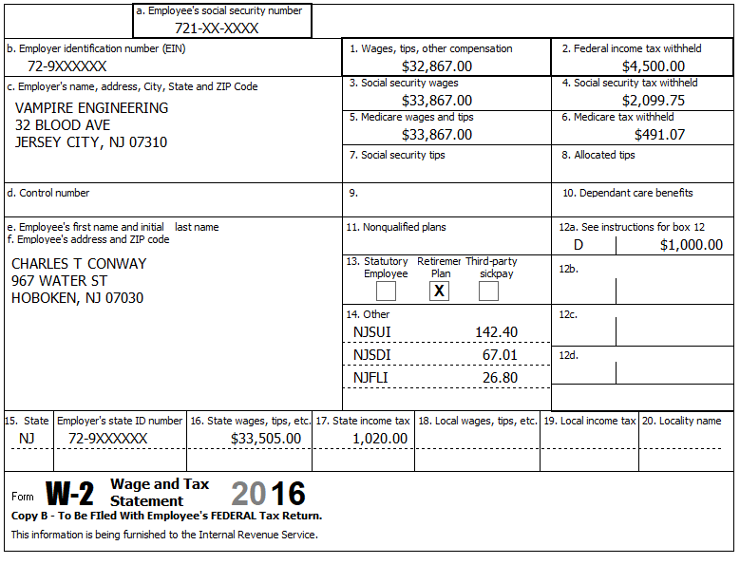

Federal Refund: 3,782 NJ Refund Amount: 538

Step 3 W-2 Smart Kids Charter School

W-2 Smart Kids Charter School | Add W-2 Statement | Hint: W-2 is for Carol  Hint: Make corrections so that information matches the information on the paper W-2  Hint: If the name and address of the employer come up after inputting the employer Identification Number, check that the information is correct  Hint: Always round up for amounts ending in --.50  Hint: Box 14 NJ Codes are selected from drop down menu. All other entries in box 14 are lumped under “Other”  Hint: If NJ State EIN auto populates, check to be sure it is correct  TS: Click continue NJ warning  TS: Click Continue to go back to Income
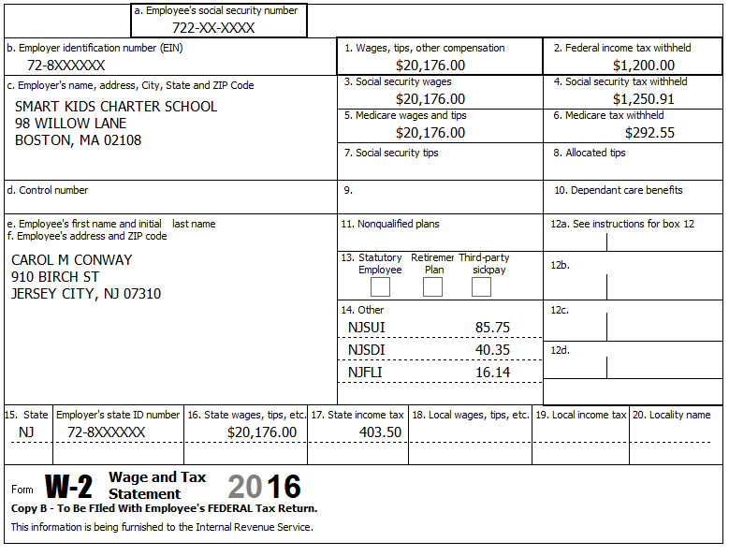

1,250.91

Federal Refund: 1,879 NJ Refund Amount: 578
Step 4 Interest 1099-INT

TP Form / Note | TS Screen | Notes
1099-INT  PNC Bank | Interest or Dividend Income  Interest Income, Form 1099-INT/ 1099-DIV- Begin  Interest or Dividend Income -Begin  Interest Income, Form 1099-INT,Form 1099-OID…..  Continue | Hint: Select for Taxpayer  Enter values that apply  Continue – Back to Income

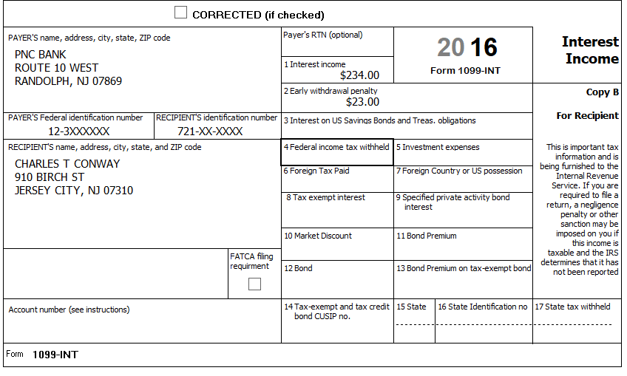

Federal Refund: 1,841 NJ Refund Amount: 573

Step 5 Unemployment 1099-G

TP Form / Note | TS Screen | Notes
1099-G  NJ Dep of Labor | UnemploymentCompensation Form 1099-G Box 1 – Begin  Add or Edit a 1099-G - Begin | TS: This 1099G worksheet is for the: Charles Conway  Hint: Phone number not required  Hint: State information not required  Continue

Charles lost his job in August of the current tax year and collected unemployment for the balance of the year.

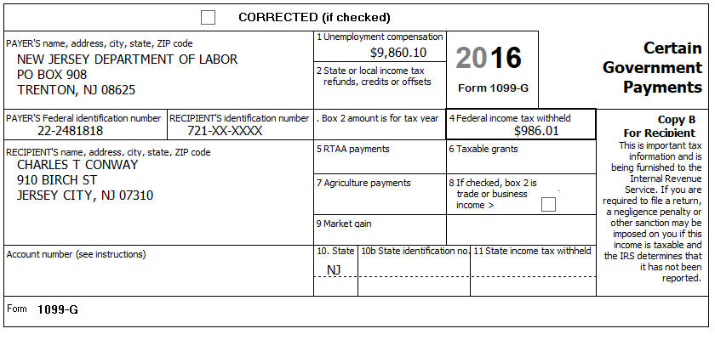

Federal Refund: 1,250 NJ Refund Amount: 573

Step 6 Federal Deductions, Adjustments & Credits
TP Form / Note | TS Screen | Notes
 | Left Menu - Federal Section -Deductions  Enter Myself  Itemized Deductions  Taxes You Paid | Go to the Sales Tax Worksheet and enter NJ, Zip Code, and 366 days living in the state  Continue back to Health Insurance
 | Compare Standard vs Itemized Deductions  Left Menu - Federal Section  Deductions  Enter Myself  Compare Deductions - Begin | Check to see if using itemized deductions or standard deductions.  Itemized =1,802  Std = 12,600  Continue back to Health Insurance

Federal Refund: 1,250 NJ Refund Amount: 573

Step 7 Health Insurance

TP Form / Note | TS Screen | Notes
G-Note 2 | Left Menu -Health Insurance  Start Questionnaire | Answer questions in the Health Insurance Section

Every person on the return had health insurance that met Minimum Essential Coverage rules for the entire year. They did not purchase it through the marketplace.

Federal Refund: 1,250 NJ Refund Amount: 573

Step 8 New Jersey Return

TP Form / Note | TS Screen | Notes
I-Note 1 & 3  G-Note 2,3 | State Return –Edit  Enter Myself  Basic Information  Credits  - ` Property Tax/Deduction  Tax  - Use Tax on Out of State Purchase | Hint: Use the NJ Checklist to enter NJ items  HINT: Check Basic Information – Default values will not appear as selected  Hint: Use scratch pad at TP4F to determine the proper value for Property Tax Paid  Hint: Property Taxes Paid = (rent*.18). [(2000x9)+ (1000x3)]x.18= 3,780  Hint: Taxpayer meets Property Tax Eligibility Requirements  Hint: Use scratch pad to determine Use tax on TV purchase = 105  Hint: Taxpayer was not a homeowner in 2016.  Continue back to the beginning of the State Return
The Conways moved from an apartment in Hoboken to an apartment in Jersey City on September 30 of the current tax year. They paid $2,000/month rent in Hoboken through September and $1,000/month in Jersey City starting in October.
In January of the tax year the Conways purchased a 50” LCD TV from Amazon.com and did not pay sales tax on the purchase amount of $1,500.00. The sales tax amount (7% in 2016) would have been $105

Federal Refund: 1,250 NJ Refund Amount: 547

Step 9 Prepare for e-file

Intake Sheet  Supplemental Intake Sheet  G Note 5 | Left Menu – e-file – | TS – Clear up any diagnostic messages (if any)  TS: Select Federal Return Type “E:file: Direct Deposit”  TS: No entries in Fees section except for Client email address  TS – Pin numbers for e-file are automatically selected  TS: Select State Refund Type “E:file: Direct Deposit”  TS: Enter Bank Information – Name of Bank not required  TS: Skip Third Party Designee Info  TS – Questions – Answer questions from Intake sheet Part VII, lines 5.6 and 7, Supplemental Intake Sheet,  TS: Skip TP ID Information Screen  Save  You are Done

They want to handle any state refund / amount due like their federal refund / amount due

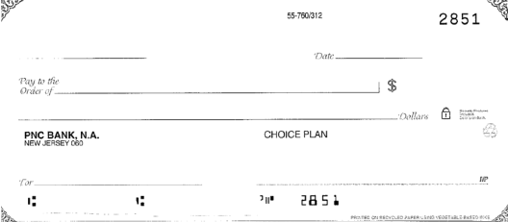
Charles T. & Carol M. Conway
910 Birch Street
Jersey City, NJ 07310
123456789
12345678901

Federal Refund: 1,250 NJ Refund Amount: 547

